Supporting Information

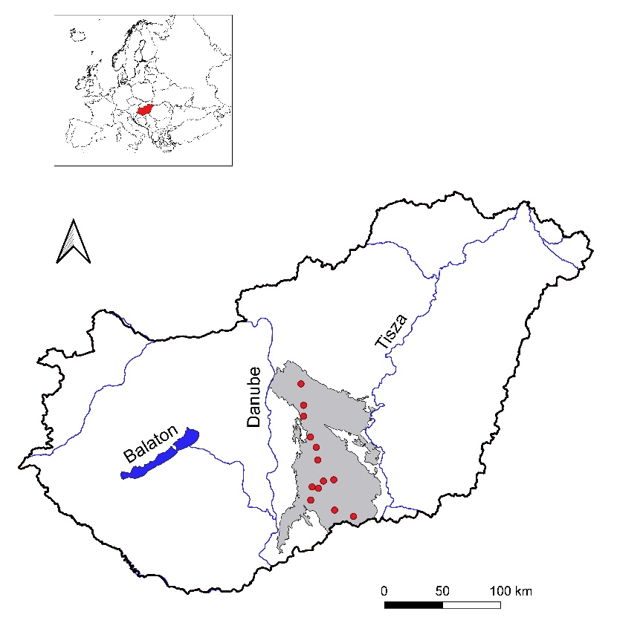
Figure S1. The position of the 13 study sites (red dots) in the Kiskunság Sand Ridge (gray) between the Rivers Danube and Tisza in Hungary. The inset shows the position of Hungary in Europe.
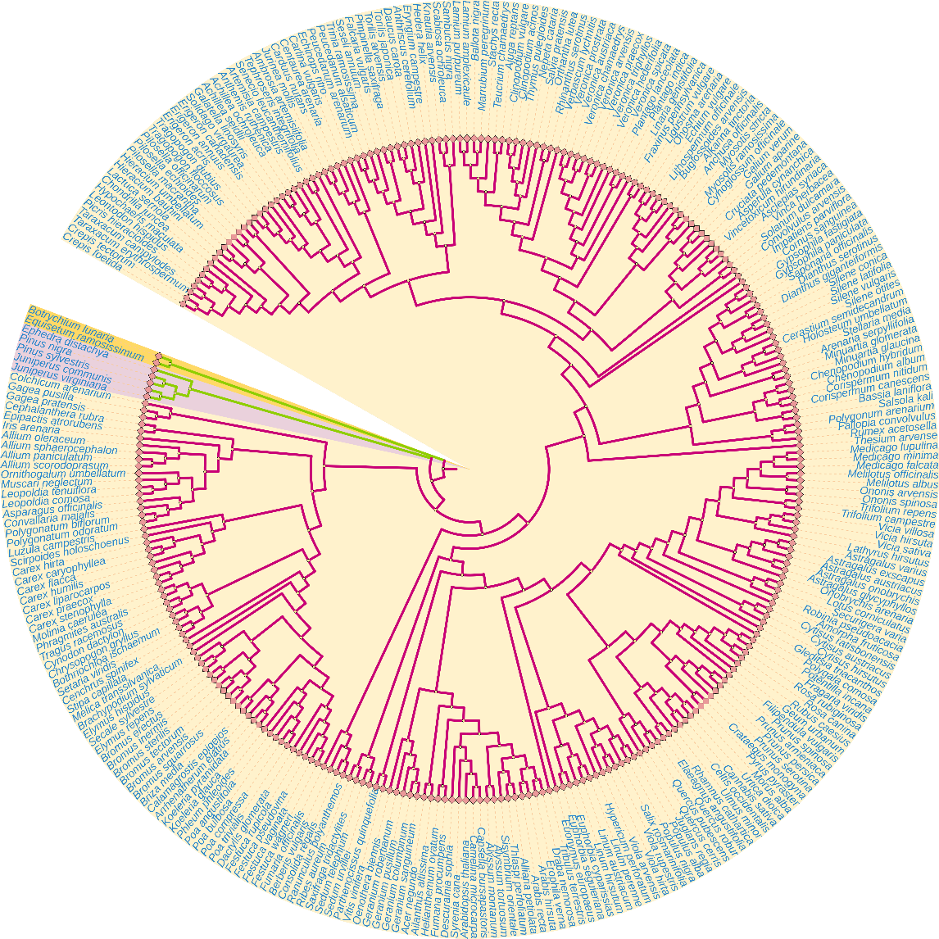
Figure S2. Phylogenetic tree containing 289 species. The orange zone includes two pteridophyte species, the purple zone includes five gymnosperms species, while the remaining species are angiosperms.

Table S1 The 13 study sites used in this study with coordinates and elevation, and the distribution of relevés across habitats and sites. Habitat type abbreviations are according to the caption of Figure 3.

Study sites | Coordinates |  | Altitude | Number of relevés
 |  |  | (m a.s.l.) | LF | MF | SF | NE | SE | CG | OP | OA
Ásotthalom | N 46°13' | E 19°47'26" | 111–115 | 5 | 5 | 5 | 5 | 5 | 5 | 5 | 5
Bócsa | N 46°41' | E 19°28' | 110–117 | 5 | 5 | 5 | 5 | 5 | 1 | 5 | 5
Bodoglár | N 46°31' | E 19°37' | 114–123 | 5 | 5 | 5 | 5 | 5 | 5 | 5 | 5
Csévharaszt | N 47°17'26" | E 19°23'30" | 125–137 | 3 | 4 | 5 | 5 | 5 | 4 | 5 | ‒
Fülöpháza | N 46°52' | E 19°25' | 105–119 | 10 | 5 | 5 | 5 | 5 | 5 | 5 | 11
Imrehegy | N 46°29' | E 19°22' | 121–133 | 5 | 5 | 5 | 5 | 5 | 1 | 5 | 5
Kéleshalom | N 46°23' | E 19°20' | 137–147 | 1 | 5 | 5 | 5 | 5 | 5 | 5 | 5
Négyestelep | N 46°17' | E 19°35'40" | 131–137 | 5 | 5 | 5 | 5 | 5 | 5 | 5 | 5
Orgovány | N 46°47'30" | E 19°28' | 105–113 | 5 | 5 | 5 | 5 | 5 | 5 | 5 | 5
Pirtó | N 46°28' | E 19°26' | 124–132 | 3 | 5 | 5 | 5 | 5 | 5 | 5 | 5
Táborfalva | N 47°7' | E 19°23' | 116–124 | 4 | 5 | 5 | 5 | 5 | ‒ | 5 | ‒
Tatárszentgyörgy | N 47°2' | E 19°22' | 102–111 | 5 | 5 | 5 | 5 | 5 | 4 | 5 | 5
Tázlár | N 46°31' | E 19°30' | 116–126 | 4 | 5 | 5 | 5 | 5 | 5 | 5 | 4

Table S2. Details of the nine traits used for the functional diversity analyses
Trait | Description | Data type | Source
Start of flowering | The season in which the species starts flowering in Hungary | Nominal with three levels: blooming from early spring (Months 1 to 4); blooming from early summer (Months 5 and 6); blooming from late summer (Months 7 to 9) | Király (2009)
Flowering duration | Duration of the flowering period in Hungary | Numeric (number of months) | Király (2009)
Specific leaf area (SLA) | The ratio of leaf area to leaf dry weight | Numeric (mm²/mg) | Kleyer et al. (2008); Lhotsky et al. (2016); E-Vojtkó et al. (2020); Gyalus et al. (2022); McIntosh-Buday et al. (2022)
Mean height | The mean height of the aboveground shoot (or the length of the shoots in case of vines) for adult plants | Numeric (cm) | Király (2009)
Thousand seed mass | Average weight of one thousand seeds | Numeric (g) | Török et al. (2013, 2016); Royal Botanic Gardens Kew (2017)
Life form | Raunkiær’s life form of the species, based on the perennating organs (seeds or buds) and (in case of the latter) the vertical position of buds | Fuzzy coding with eight levels: tree and shrub; semishrub; dwarf shrub; hemicryptophyte; geophyte; therophyte; hemitherophyte; epiphyte | Horváth et al. (1995); Király (2009)
Seed dispersal | The employed dispersal vector(s) | Fuzzy coding with four levels: anemochor; rainwash; autochor; zoochor | Fitter and Peat (1994); Csontos et al. (2002); Royal Botanic Gardens Kew (2017); USDA Forest Service (2017)
Pollination type | The employed pollen vector(s) | Fuzzy coding with three levels: insects; wind; self-pollination | Fitter and Peat (1994); Kühn el al. (2004); USDA Forest Service (2017)
Reproduction type | The mode of reproduction | Fuzzy coding with two levels: generative; vegetative | Kühn et al. (2004)

Csontos, P., Tamás, J., & Tobisch, T. (2002). A magyar flóra magterjesztési-mód adatbázisának bemutatása, elemzési példákkal: a szociális magatartási típusok értékelése. In É. Salamon-Albert (Ed.), Magyar botanikai kutatások az ezredfordulón (pp. 557–569). PTE Növénytani Tanszék.
E-Vojtkó, A., Balogh, N., Deák, B., Kelemen, A., Kis, S., Kiss, R., Lovas-Kiss, Á., Löki, V., Lukács, K., Molnár, V. A., Nagy, T., Sonkoly, J., Süveges, K., Takács, A., Tóth, E., Tóth, K., Tóthmérész, B., Török, P., Valkó, O., Vojtkó, A., & Lukács, B. A. (2020). Leaf trait records of vascular plant species in the Pannonian flora with special focus on endemics and rarities. Folia Geobotanica, 55, 73–79. https://doi.org/10.1007/s12224-020-09363-7
Fitter, A. H., & Peat, H. J. (1994). The ecological flora database. Journal of Ecology, 82(2), 415–425. https://doi.org/10.2307/2261309
Gyalus, A., Barabás, S., Berki, B., Botta-Dukát, Z., Kabai, M., Lhotsky, B., & Csecserits, A. (2022). Plant trait records of the Hungarian and Serbian flora and methodological description of some hardly measurable plant species. Acta Botanica Hungarica (in press)
Horváth, F., Dobolyi, Z. K., Morschhauser, T., Lőkös, L., Karas, L., & Szerdahelyi, T. (1995). FLÓRA adatbázis 1.2. MTA ÖBKI.
Király, G. (Ed.) (2009). Új magyar füvészkönyv. Aggtelek National Park.
Kleyer, M., Bekker, R.M., Knevel, I.C., Bakker, J. P., Thompson, K., Sonnenschein, M., Poschlod, P., Van Groenendael, J. M., Klimeš, L., Klimešová, J., Klotz, S., Rusch, G. M., Hermy, M., Adriaens, D., Boedeltje, G., Bossuyt, B., Dannemann, A., Endels, P., Götzenberger, L., Hodgson, J.G., et al. (2008). The LEDA Traitbase: a database of life-history traits of the Northwest European flora. Journal of Ecology, 96(6), 1266–1274. https://doi.org/10.1111/j.1365-2745.2008.01430.x
Kühn, I., Durka, W., & Klotz, S. (2004). BiolFlor – a new plant-trait database as a tool for plant invasion ecology. Diversity and Distributions, 10(5-6), 363–365.
Lhotsky, B., Csecserits, A., Kovács, B., & Botta-Dukát, Z. (2016). New plant trait records of the Hungarian flora. Acta Botanica Hungarica, 58(3-4), 397–400. https://doi.org/10.1556/abot.58.2016.3-4.8
McIntosh-Buday, A., Sonkoly, J., Takács, A., Balogh, N., Kovacsics-Vári, G., Teleki, B., Süveges, K., Tóth, K., Hábenczyus, A. A., Lukács, B. A., Lovas-Kiss, Á., Löki, V., Tomasovszky, A., Tóthmérész, B., Török, P., & Tóth, E. (2022). New data of plant leaf traits from Central Europe. Data in Brief, 42, 108286. https://doi.org/10.1016/j.dib.2022.108286
Royal Botanic Gardens Kew (2017). Seed information database (SID) version 7.1. http://data.kew.org/sid
Török, P., Miglécz, T., Valkó, O., Tóth, K., Kelemen, A., Albert, Á. J., Matus, G., Molnár, V. A., Ruprecht, E., Papp, L., Deák, B., Horváth, O., Takács, A., Hüse, B., & Tóthmérész, B. (2013). New thousand-seed weight records of the Pannonian flora and their application in analysing social behaviour types. Acta Botanica Hungarica, 55(3-4), 429–472. https://doi.org/10.1556/abot.55.2013.3-4.17
Török, P., Tóth, E., Tóth, K., Valkó, O., Deák, B., Kelbert, B., Bálint, P., Radócz, S., Kelemen, A., Sonkoly, J., Miglécz, T., Matus, G., Takács, A., Molnár, V. A., Süveges, K., Papp, L., Papp Jr, L., Tóth, Z., Baktay, B., Málnási Csizmadia, G., et al. (2016). New measurements of thousand-seed weights of species in the Pannonian flora. Acta Botanica Hungarica, 58(1-2), 187–198. https://doi.org/10.1556/034.58.2016.1-2.10
USDA Forest Service (2017). Fire effects information system. USDA Forest Service Rocky Mountain Research Station. https://www.feis-crs.org/feis/

Table S3: Statistical results of the pairwise comparisons of species composition. Habitat type abbreviations are according to the caption of Figure 3.

Pair | F. model | R² | p
LF-MF | 1.92 | 0.016 | 1.000
LF-SF | 10.9 | 0.082 | 0.028
LF-NE | 17.8 | 0.127 | 0.028
LF-SE | 23.2 | 0.159 | 0.028
LF-CG | 94.8 | 0.467 | 0.028
LF-OP | 131.2 | 0.516 | 0.028
LF-OA | 124.7 | 0.514 | 0.028
MF-SF | 6.87 | 0.051 | 0.028
MF-NE | 12.9 | 0.092 | 0.028
MF-SE | 19.4 | 0.133 | 0.028
MF-CG | 92.1 | 0.451 | 0.028
MF-OP | 129.5 | 0.505 | 0.028
MF-OA | 123.7 | 0.503 | 0.028
SF-NE | 3.41 | 0.026 | 0.028
SF-SE | 6.77 | 0.050 | 0.028
SF-CG | 69.6 | 0.381 | 0.028
SF-OP | 101.3 | 0.442 | 0.028
SF-OA | 104.0 | 0.458 | 0.028
NE-SE | 5.96 | 0.045 | 0.028
NE-CG | 54.7 | 0.326 | 0.028
NE-OP | 85.0 | 0.399 | 0.028
NE-OA | 95.1 | 0.436 | 0.028
SE-CG | 53.8 | 0.323 | 0.028
SE-OP | 61.1 | 0.323 | 0.028
SE-OA | 78.2 | 0.389 | 0.028
CG-OP | 61.6 | 0.353 | 0.028
CG-OA | 70.3 | 0.394 | 0.028
OP-OA | 42.5 | 0.257 | 0.028

Table S4. Statistical results of the pairwise comparisons of species number, Shannon diversity, overall functional diversity, phylogenetic diversity with all species, and phylogenetic diversity with non-angiosperm species excluded. Habitat type abbreviations are according to the caption of Figure 3.
Pair | Species richness |  | Shannon diversity |  | Overall FD-SES.RaoQ
Pair | t | p | t | p | t | p
LF-MF | -2.15 | 0.884 | -0.72 | 1.000 | -1.09 | 1.000
LF-SF | -8.26 | <0.001 | -1.99 | 1.000 | -1.20 | 1.000
LF-NE | -15.6 | <0.001 | -5.68 | <0.001 | -1.61 | 1.000
LF-SE | -12.5 | <0.001 | -4.60 | <0.001 | -2.96 | 0.091
LF-CG | -7.34 | <0.001 | -2.10 | 1.000 | 19.6 | <0.001
LF-OP | -4.19 | <0.001 | -3.82 | 0.004 | 15.3 | <0.001
LF-OA | -3.88 | 0.003 | -4.89 | <0.001 | 15.2 | <0.001
MF-SF | -6.33 | <0.001 | -1.29 | 1.000 | -0.10 | 1.000
MF-NE | -14.1 | <0.001 | -5.06 | <0.001 | -0.52 | 1.000
MF-SE | -10.8 | <0.001 | -3.96 | 0.002 | -1.90 | 1.000
MF-CG | -5.46 | <0.001 | -1.45 | 1.000 | 20.9 | <0.001
MF-OP | -2.09 | 1.000 | -3.16 | 0.047 | 16.8 | <0.001
MF-OA | -1.81 | 1.000 | -4.24 | <0.001 | 16.5 | <0.001
SF-NE | -7.99 | <0.001 | -3.77 | 0.005 | -0.42 | 1.000
SF-SE | -4.56 | <0.001 | -2.67 | 0.219 | -1.80 | 1.000
SF-CG | 0.47 | 1.000 | -0.25 | 1.000 | 21.1 | <0.001
SF-OP | 4.27 | <0.001 | -1.87 | 1.000 | 16.9 | <0.001
SF-OA | 4.34 | <0.001 | -2.99 | 0.084 | 16.6 | <0.001
NE-SE | 3.46 | 0.017 | 1.10 | 1.000 | -1.39 | 1.000
NE-CG | 7.83 | <0.001 | 3.25 | 0.034 | 21.5 | <0.001
NE-OP | 12.2 | <0.001 | 1.90 | 1.000 | 17.4 | <0.001
NE-OA | 11.9 | <0.001 | 0.68 | 1.000 | 17.0 | <0.001
SE-CG | 4.69 | <0.001 | 2.23 | 0.732 | 22.8 | <0.001
SE-OP | 8.79 | <0.001 | 0.80 | 1.000 | 18.7 | <0.001
SE-OA | 8.69 | <0.001 | -0.39 | 1.000 | 18.4 | <0.001
CG-OP | 3.52 | 0.013 | -1.49 | 1.000 | -5.40 | <0.001
CG-OA | 3.64 | 0.008 | -2.55 | 0.308 | -5.16 | <0.001
OP-OA | 0.22 | 1.000 | -1.17 | 1.000 | 0.15 | 1.000

Table S4 (continued).
Pair | Phylogenetic-SES.RaoQ |  | Phylogenetic-SES.RaoQ-g
Pair | t | p | t | p
LF-MF | -3.61 | 0.010 | -0.83 | 1.000
LF-SF | -4.55 | <0.001 | -0.71 | 1.000
LF-NE | -5.36 | <0.001 | -0.67 | 1.000
LF-SE | -1.88 | 1.000 | 0.16 | 1.000
LF-CG | 4.73 | <0.001 | 10.7 | <0.001
LF-OP | 5.82 | <0.001 | 14.0 | <0.001
LF-OA | 5.98 | <0.001 | 16.4 | <0.001
MF-SF | -0.95 | 1.000 | 0.12 | 1.000
MF-NE | -1.77 | 1.000 | 0.16 | 1.000
MF-SE | 1.77 | 1.000 | 1.02 | 1.000
MF-CG | 8.24 | <0.001 | 11.6 | <0.001
MF-OP | 9.64 | <0.001 | 15.2 | <0.001
MF-OA | 9.65 | <0.001 | 17.4 | <0.001
SF-NE | -0.83 | 1.000 | 0.04 | 1.000
SF-SE | 2.73 | 0.184 | 0.90 | 1.000
SF-CG | 9.15 | <0.001 | 11.6 | <0.001
SF-OP | 10.6 | <0.001 | 15.1 | <0.001
SF-OA | 10.6 | <0.001 | 17.4 | <0.001
NE-SE | 3.56 | 0.011 | 0.86 | 1.000
NE-CG | 9.92 | <0.001 | 11.5 | <0.001
NE-OP | 11.5 | <0.001 | 15.1 | <0.001
NE-OA | 11.4 | <0.001 | 17.3 | <0.001
SE-CG | 6.62 | <0.001 | 10.7 | <0.001
SE-OP | 7.90 | <0.001 | 14.2 | <0.001
SE-OA | 7.95 | <0.001 | 16.5 | <0.001
CG-OP | 0.70 | 1.000 | 2.44 | 0.419
CG-OA | 0.95 | 1.000 | 4.89 | <0.001
OP-OA | 0.29 | 1.000 | 2.67 | 0.222

Table S5. Significant (P < 0.001) diagnostic species of the eight habitats with phi coefficients > 0.200. Habitat type abbreviations are according to the caption of Figure 3.

Species | LF | MF | SF | NE | SE | CG | OP | OA
Achillea pannonica |  |  |  | 0.259
Ailanthus altissima | 0.235
Alkanna tinctoria |  |  |  |  |  |  | 0.561 | 0.515
Allium sphaerocephalon |  |  |  |  |  | 0.249
Alyssum tortuosum |  |  |  |  |  |  | 0.330 | 0.264
Anthriscus cerefolium | 0.288 | 0.242
Arenaria serpyllifolia |  |  |  |  |  |  | 0.436 | 0.372
Artemisia campestris |  |  |  |  |  |  | 0.214 | 0.287
Asparagus officinalis |  |  | 0.358 | 0.281 | 0.266
Asperula cynanchica |  |  |  | 0.279
Berberis vulgaris | 0.337 | 0.397 | 0.324 | 0.232
Bothriochloa ischaemum |  |  |  |  |  | 0.241
Bromus squarrosus |  |  |  |  |  |  |  | 0.601
Bromus sterilis | 0.257 | 0.208
Bromus tectorum |  |  |  |  |  |  |  | 0.433
Calamagrostis epigeios |  |  |  | 0.284 | 0.284
Carex caryophyllea |  |  |  |  |  | 0.429
Carlina vulgaris |  |  |  | 0.429
Celtis occidentalis | 0.319 | 0.408 | 0.410 | 0.254
Centaurea arenaria |  |  |  |  |  |  | 0.397 | 0.552
Cerastium semidecandrum |  |  |  |  |  | 0.527 | 0.336
Chenopodium album |  |  |  |  | 0.268
Chondrilla juncea |  |  |  |  | 0.215
Conyza canadensis |  |  |  |  |  |  |  | 0.218
Corispermum canescens |  |  |  |  |  |  |  | 0.327
Cornus sanguinea | 0.237
Crataegus monogyna | 0.37 | 0.354 | 0.321 | 0.321 | 0.221
Crepis rhoeadifolia |  |  |  |  |  |  | 0.373 | 0.388
Cynodon dactylon |  |  |  |  | 0.282
Cynoglossum officinale | 0.20 | 0.235 | 0.211
Dianthus pontederae |  |  |  |  |  | 0.308
Equisetum ramosissimum |  |  |  |  |  | 0.257
Erophila verna |  |  |  |  |  |  | 0.708
Eryngium campestre |  |  |  | 0.30 |  | 0.262
Euonymus europaeus | 0.271
Euphorbia cyparissias |  |  |  | 0.205 | 0.281 | 0.223
Euphorbia seguieriana |  |  |  |  |  |  | 0.400 | 0.567
Fallopia convolvulus | 0.244 | 0.308
Festuca pseudovina |  |  |  |  |  | 0.214
Festuca rupicola, F.valesiaca |  |  |  |  |  | 0.650
Festuca vaginata |  |  |  |  | 0.244 |  | 0.421 | 0.297
Festuca wagneri |  |  |  |  |  |  | 0.223
Filipendula vulgaris |  |  |  |  |  | 0.237
Fumana procumbens |  |  |  |  |  |  | 0.563 | 0.243
Galium aparine | 0.278 | 0.325
Galium verum |  |  |  | 0.219 | 0.219 | 0.386
Geum urbanum | 0.263
Helianthemum ovatum |  |  |  | 0.225 |  | 0.287
Hieracium echioides |  |  |  | 0.261
Holosteum umbellatum |  |  |  |  |  | 0.336 | 0.497 | 0.490
Juniperus communis |  |  | 0.223 | 0.318
Kochia laniflora |  |  |  |  |  |  | 0.430 | 0.699
Koeleria cristata |  |  |  |  |  | 0.684
Koeleria glauca |  |  |  |  |  |  | 0.244
Leontodon hispidus |  |  |  | 0.320
Ligustrum vulgare | 0.259 | 0.323 | 0.311 | 0.311
Linaria genistifolia |  |  |  |  |  |  |  | 0.221
Lithospermum officinale |  | 0.334
Medicago falcate |  |  |  | 0.307
Medicago minima |  |  |  |  |  |  | 0.378 | 0.224
Minuartia glaucina |  |  |  |  |  |  | 0.343 | 0.248
Myosotis stricta |  |  |  |  |  |  | 0.296
Ononis spinose |  |  |  |  |  | 0.246
Padus serotine |  | 0.212
Phleum phleoides |  |  |  |  |  | 0.359
Pimpinella saxifraga |  |  |  | 0.308
Pinus nigra |  |  |  | 0.238
Poa angustifolia |  |  | 0.336 | 0.368 |  | 0.224
Poa bulbosa |  |  |  |  |  |  | 0.379 | 0.401
Polygala comosa |  |  |  | 0.329
Polygonum arenarium |  |  |  |  |  |  | 0.569 | 0.506
Populus alba | 0.288 | 0.288 | 0.288 | 0.288 | 0.288
Potentilla arenaria |  |  |  | 0.241 |  | 0.432 | 0.226
Prunus spinose | 0.258 | 0.284 |  | 0.228
Rhamnus catharticus | 0.306 | 0.261 | 0.266 | 0.327
Robinia pseudoacacia | 0.327
Rubus caesius | 0.209
Salix rosmarinifolia |  |  |  |  |  | 0.334
Salsola kali |  |  |  |  |  |  |  | 0.358
Saxifraga tridactylites |  |  |  |  |  | 0.342
Scabiosa ochroleuca |  |  |  | 0.408
Scirpoides holoschoenus |  |  |  |  |  | 0.617
Secale sylvestre |  |  |  |  |  |  | 0.217 | 0.759
Senecio vernalis |  |  |  |  | 0.249
Seseli annuum |  |  |  | 0.350
Setaria viridis |  |  |  |  |  |  |  | 0.506
Silene conica |  |  |  |  |  |  | 0.389 | 0.390
Solidago virgaurea |  |  |  | 0.240
Stellaria media | 0.212
Stipa borysthenica, S. capillata |  |  |  |  | 0.224 | 0.348 | 0.392 | 0.319
Syrenia cana |  |  |  |  |  |  | 0.378 | 0.532
Taraxacum laevigatum agg. |  | 0.262 | 0.237 | 0.313
Taraxacum officinale agg. | 0.213
Tephroseris integrifolia |  |  |  | 0.249
Teucrium chamaedrys |  |  |  | 0.344 |  | 0.425
Thesium ramosum |  |  |  | 0.307
Thymus pannonicus |  |  |  | 0.321 |  | 0.321
Tragopogon floccosus |  |  |  | 0.217
Tragus racemosus |  |  |  |  |  |  |  | 0.681
Tribulus terrestris |  |  |  |  |  |  |  | 0.253
Trinia ramosissima |  |  |  |  |  |  | 0.217
Verbascum lychnitis |  |  |  |  | 0.221 | 0.426
Veronica praecox |  |  |  |  |  |  |  | 0.208
Veronica prostrata |  |  |  |  |  | 0.223
Vincetoxicum hirundinaria |  | 0.213
Viola arvensis |  |  |  |  |  |  |  | 0.271
Viola rupestris |  |  |  | 0.428

Table S6. Statistical results between observed SES.RaoQ values and the null model expectation (two-sided Wilcoxon signed rank test).
Habitat | SES.RaoQ  (FD for all traits) |  | SES.RaoQ  (PD for all species) |  | SES.RaoQ-g  (PD with only angiosperm species)
Habitat | V | p | V | p | V | p
LF | 1723 | <0.001 | 295 | <0.001 | 1342 | 0.002
MF | 2072 | <0.001 | 1092 | 0.731 | 1994 | <0.001
SF | 2145 | <0.001 | 1292 | 0.152 | 1869 | <0.001
NE | 2138 | <0.001 | 1319 | 0.062 | 1992 | <0.001
SE | 2144 | <0.001 | 951 | 0.429 | 1645 | <0.001
CG | 3 | <0.001 | 0 | <0.001 | 13 | <0.001
OP | 245 | <0.001 | 71 | <0.001 | 16 | <0.001
OA | 71 | <0.001 | 45 | <0.001 | 18 | <0.001

Table S6 (continued)
Habitat | SES.RaoQ  (FD for flowering time) |  | SES.RaoQ  (FD for seed dispersal) |  | SES.RaoQ  (FD for reproduction type) |  | SES.RaoQ  (FD for plant height)
Habitat | V | p | V | p | V | P | V | p
LF | 1700 | <0.001 | 1576 | <0.001 | 1829 | <0.001 | 1826 | <0.001
MF | 2077 | <0.001 | 2027 | <0.001 | 2080 | <0.001 | 2080 | <0.001
SF | 2114 | <0.001 | 2117 | <0.001 | 2145 | <0.001 | 2145 | <0.001
NE | 2043 | <0.001 | 2004 | <0.001 | 2145 | <0.001 | 2145 | <0.001
SE | 2144 | <0.001 | 2112 | <0.001 | 2145 | <0.001 | 2145 | <0.001
CG | 23 | <0.001 | 212 | <0.001 | 73 | <0.001 | 51 | <0.001
OP | 736 | 0.028 | 798 | 0.07 | 831 | 0.115 | 363 | <0.001
OA | 515 | 0.003 | 250 | <0.001 | 327 | <0.001 | 0 | <0.001

Table S6 (continued)
Habitat | SES.RaoQ  (FD for life form) |  | SES.RaoQ  (FD for SLA) |  | SES.RaoQ  (FD for seed mass) |  | SES.RaoQ  (FD for pollination type)
Habitat | V | p | V | p | V | P | V | p
LF | 11 | <0.001 | 212 | <0.001 | 1780 | <0.001 | 1754 | <0.001
MF | 6 | <0.001 | 644 | 0.008 | 1973 | <0.001 | 1571 | <0.001
SF | 248 | <0.001 | 119 | <0.001 | 1586 | <0.001 | 1032 | 0.79
NE | 138 | <0.001 | 237 | <0.001 | 1424 | 0.022 | 1143 | 0.647
SE | 578 | 0.001 | 94 | <0.001 | 979 | 0.543 | 975 | 0.526
CG | 64 | <0.001 | 494 | 0.167 | 311 | 0.002 | 1032 | <0.001
OP | 38 | <0.001 | 94 | <0.001 | 240 | <0.001 | 1934 | <0.001
OA | 179 | <0.001 | 501 | 0.002 | 369 | <0.001 | 1601 | <0.001

Table S7. Statistical results of the pairwise comparisons of functional diversity for individual traits. Habitat type abbreviations are according to the caption of Figure 3.
 | Flowering time-SES.RaoQ |  | Seed dispersal-SES.RaoQ |  | Reproduction type-SES.RaoQ |  | Mean plant height-SES.RaoQ
 | T | p | t | p | t | p | t | p
LF-MF | -1.33 | 1.000 | -1.37 | 1.000 | -1.55 | 1.000 | -1.04 | 1.000
LF-SF | -1.20 | 1.000 | -2.34 | 0.554 | -0.63 | 1.000 | -4.61 | <0.001
LF-NE | -0.41 | 1.000 | -1.85 | 1.000 | -2.33 | 0.572 | -5.77 | <0.001
LF-SE | -1.48 | 1.000 | -2.73 | 0.183 | -1.28 | 1.000 | -9.24 | <0.001
LF-CG | 17.1 | <0.001 | 8.17 | <0.001 | 26.2 | <0.001 | 17.2 | <0.001
LF-OP | 8.19 | <0.001 | 6.90 | <0.001 | 22.5 | <0.001 | 15.0 | <0.001
LF-OA | 9.33 | <0.001 | 12.5 | <0.001 | 25.5 | <0.001 | 20.4 | <0.001
MF-SF | 0.14 | 1.000 | -0.98 | 1.000 | 0.94 | 1.000 | -3.63 | 0.009
MF-NE | 0.94 | 1.000 | -0.49 | 1.000 | -0.79 | 1.000 | -4.82 | <0.001
MF-SE | -0.15 | 1.000 | -1.39 | 1.000 | 0.28 | 1.000 | -8.36 | <0.001
MF-CG | 18.7 | <0.001 | 9.62 | <0.001 | 28.1 | <0.001 | 18.5 | <0.001
MF-OP | 9.71 | <0.001 | 8.44 | <0.001 | 24.5 | <0.001 | 16.4 | <0.001
MF-OA | 10.8 | <0.001 | 14.1 | <0.001 | 27.4 | <0.001 | 21.7 | <0.001
SF-NE | 0.81 | 1.000 | 0.50 | 1.000 | -1.73 | 1.000 | -1.19 | 1.000
SF-SE | -0.28 | 1.000 | -0.40 | 1.000 | -0.66 | 1.000 | -4.75 | <0.001
SF-CG | 18.6 | <0.001 | 10.6 | <0.001 | 27.3 | <0.001 | 21.9 | <0.001
SF-OP | 9.61 | <0.001 | 9.47 | <0.001 | 23.6 | <0.001 | 20.1 | <0.001
SF-OA | 10.7 | <0.001 | 15.1 | <0.001 | 26.6 | <0.001 | 25.3 | <0.001
NE-SE | -1.09 | 1.000 | -0.90 | 1.000 | 1.07 | 1.000 | -3.56 | 0.012
NE-CG | 17.9 | <0.001 | 10.1 | <0.001 | 28.9 | <0.001 | 23.1 | <0.001
NE-OP | 8.81 | <0.001 | 8.97 | <0.001 | 25.4 | <0.001 | 21.3 | <0.001
NE-OA | 9.90 | <0.001 | 14.6 | <0.001 | 28.3 | <0.001 | 26.5 | <0.001
SE-CG | 18.9 | <0.001 | 10.9 | <0.001 | 27.9 | <0.001 | 26.4 | <0.001
SE-OP | 9.90 | <0.001 | 9.87 | <0.001 | 24.3 | <0.001 | 24.8 | <0.001
SE-OA | 10.9 | <.0001 | 15.5 | <0.001 | 27.2 | <0.001 | 29.9 | <0.001
CG-OP | 9.68 | <0.001 | -1.80 | 1.000 | -5.37 | <0.001 | -3.31 | 0.029
CG-OA | -8.25 | <0.001 | 3.72 | 0.006 | -1.98 | 1.000 | 2.15 | 0.900
OP-OA | 1.33 | 1.000 | 5.87 | <0.001 | 3.53 | 0.013 | 5.76 | <0.001

Table S7 (continued).
 | Life form-SES.RaoQ |  | Specific leaf area (SLA)-SES.RaoQ |  |  | Thousand seed mass-SES.RaoQ |  |  | Pollination type-SES.RaoQ
 | t | p | t | p | t |  | p | t |  | p
LF-MF | -1.62 | 1.000 | -1.98 | 1.000 | 1.99 |  | 1.000 | 2.46 |  | 0.404
LF-SF | -6.47 | <0.001 | 1.85 | 1.000 | 5.16 |  | <0.001 | 6.22 |  | <0.001
LF-NE | -6.36 | <0.001 | 1.51 | 1.000 | 5.82 |  | <0.001 | 5.53 |  | <0.001
LF-SE | -9.54 | <0.001 | 3.08 | 0.061 | 8.49 |  | <0.001 | 6.73 |  | <0.001
LF-CG | -3.21 | 0.040 | -1.91 | 1.000 | 10.39 |  | <0.001 | 2.88 |  | 0.115
LF-OP | -2.46 | 0.398 | 4.67 | <0.001 | 11.9 |  | <0.001 | 1.90 |  | 1.000
LF-OA | -6.31 | <0.001 | -2.55 | 0.309 | 10.8 |  | <0.001 | 0.32 |  | 1.000
MF-SF | -4.94 | <0.001 | 3.92 | 0.003 | 3.23 |  | 0.038 | 3.84 |  | 0.004
MF-NE | -4.84 | <0.001 | 3.57 | 0.011 | 3.91 |  | 0.003 | 3.13 |  | 0.042
MF-SE | -8.08 | <0.001 | 5.18 | <0.001 | 6.63 |  | <0.001 | 4.36 |  | <0.001
MF-CG | -1.72 | 1.000 | -0.07 | 1.000 | 8.69 |  | <0.001 | 0.60 |  | 1.000
MF-OP | -0.86 | 1.000 | 6.80 | <0.001 | 10.1 |  | <0.001 | -0.57 |  | 1.000
MF-OA | -4.78 | <0.001 | -0.62 | 1.000 | 8.95 |  | <0.001 | -2.12 |  | 0.963
SF-NE | 0.11 | 1.000 | -0.35 | 1.000 | 0.69 |  | 1.000 | -0.71 |  | 1.000
SF-SE | -3.15 | 0.049 | 1.26 | 1.000 | 3.42 |  | 0.019 | 0.52 |  | 1.000
SF-CG | 2.88 | 0.118 | -3.71 | 0.006 | 5.71 |  | <0.001 | -2.97 |  | 0.088
SF-OP | 4.10 | 0.001 | 2.89 | 0.112 | 6.93 |  | <0.001 | -4.43 |  | <0.001
SF-OA | 0.04 | 1.000 | -4.44 | <0.001 | 5.82 |  | <0.001 | -5.87 |  | <0.001
NE-SE | -3.25 | 0.034 | 1.61 | 1.000 | 2.73 |  | 0.183 | 1.23 |  | 1.000
NE-CG | 2.78 | 0.161 | -3.39 | 0.021 | 5.07 |  | <0.001 | -2.31 |  | 0.597
NE-OP | 3.99 | 0.002 | 3.24 | 0.036 | 6.24 |  | <0.001 | -3.72 |  | 0.006
NE-OA | -0.07 | 1.000 | -4.10 | 0.001 | 5.16 |  | <0.001 | -5.18 |  | <0.001
SE-CG | 5.79 | <0.001 | -4.89 | <0.001 | 2.54 |  | 0.319 | -3.45 |  | 0.017
SE-OP | 7.25 | <0.001 | 1.63 | 1.000 | 3.51 |  | 0.014 | -4.95 |  | <0.001
SE-OA | 3.10 | 0.058 | -5.66 | <0.001 | 2.50 |  | 0.357 | -6.38 |  | <0.001
CG-OP | 0.93 | 1.000 | 6.39 | <0.001 | 0.72 |  | 1.000 | -1.14 |  | 1.000
CG-OA | -2.79 | 0.153 | -0.51 | 1.000 | -0.15 |  | 1.000 | -2.58 |  | 0.283
OP-OA | -3.96 | 0.003 | -7.25 | <0.001 | -0.92 |  | 1.000 | -1.57 |  | 1.000

